The Lord’s Prayer

Our Father, who art in heaven, hallowed be thy name. Thy kingdom come, Thy will be done on earth as it is in heaven. Give us this day our daily bread and forgive us our trespasses, as we forgive those who trespass against us. And lead us not into temptation, but deliver us from evil. For thine is the kingdom, and the power, and the glory, forever. Amen.
Prayer of Consecration
Breaking Bread
Prayer after Communion
Eternal God, we give you thanks for this holy mystery in which you have given yourself to us. Grant that we may go into the world in the strength of your Spirit, to give ourselves for others, in the name of Jesus Christ our Lord. Amen.
*Singing Our Faith #310 (vs. 1 & 3) “He Lives”
*Blessing and Dismissal
*Postlude

Scatter to Serve God & Neighbor

Welcome to all! We gather to praise God for the innumerable blessings given to us and to grow deeper in the Spirit. Joyfully, let us lift our hearts to God.

Chestnut Hill United Methodist Church

4660 Fort Avenue ~ Lynchburg, Virginia 24502
Church: 434-239-8423
Minister’s Cell: 434-944-7723, Minister’s Email: awhite@ves.org
Email: chestnuthillumc@comcast.net
On the Web at chestnuthillumc.net
Find us on Facebook: Chestnut Hill United Methodist Church

Chestnut Hill United Methodist Church

10:30 a.m. ~ April 5, 2026 ~ Easter Sunday
Our ministry vision for the Virginia Annual Conference is “to be
disciples of Jesus Christ who are lifelong learners, who influence others to serve.”

Welcome! Join us in worshiping God!
Prelude
Welcome and Ministry Announcements
Welcome in the name of Christ our Lord. Please register your attendance, printing your name, address, phone, and email, on the attendance pad provided on your pew. Thank you for silencing cell phones as we gather to worship God.
Invocation
*Greeting
Christ is Risen!
Christ is risen indeed! Alleluia!
This is the feast of victory for our God.
Alleluia, Alleluia!
Worthy is Christ, the Lamb who was slain, whose blood set us free to be people of God.
This is the feast of victory for our God. Alleluia, Alleluia!
Power, riches and wisdom and strength, and honor and blessing and glory are his.
This is the feast of victory for our God. Alleluia, Alleluia!
Sing with all the people of God and join in the hymn of all creation.
This is the feast of victory for our God. Alleluia, Alleluia!
Blessing and honor and glory and might be to God and the Lamb forever. Amen.
This is the feast of victory for our God. Alleluia, Alleluia!

For the Lamb who was slain has begun his reign. Alleluia.
This is the feast of victory for our God. Alleluia, Alleluia!
*Singing Our Faith #302 (vs. 1-4) “Christ the Lord Is Risen Today”

Opening Prayer
Almighty God, who through your only-begotten Son Jesus Christ overcame death and opened to us the gate of everlasting life: Grant that we, who celebrate with joy the day of the Lord’s resurrection, may be raised from the death of sin by your life-giving Spirit; through Jesus Christ our Lord, who lives and reigns with you and the Holy Spirit, one God, for ever and ever. Amen.

Greeting Friends and Neighbors

Prayer of Illumination
O risen Christ, open us to the power of your resurrection as we hear it proclaimed anew this day, that we too might rise to new life in you. Amen.

Scripture Lesson s

John 20:1-18, Matthew 28:1-10, and Luke 24:1-12
The Word of God for the people of God.

Thanks be to God.
Singing Our Faith #308 “Thine Be the Glory”
The Good News “Welcome Back”
Bringing Forward God’s Tithes and Our Gifts
*Doxology # 95 Praise God from whom all blessings flow; praise him, all Creatures here below; praise him above, ye heavenly host; praise Father, Son, and Holy Ghost. Amen.
*Prayer of Thanksgiving
Sharing of Joys and Concerns

**Calendar **
Monday, 4/6 |  | Easter Holiday ~ Church Office Closed
**Looking Ahead on the Calendar **
Sunday, 4/12 | 10:00 a.m. | Choir
Thursday, 4/16 | 10:30 a.m. | Merry Martha’s Circle
Monday, 4/20 | 7:00 p.m. | Wesleyan Group @ Walker Home. Packing Kits for Conference.
Hospital: Virginia Baptist: Steve Coleman

Birthdays Coming Up: April 10-Jeanmarie M. White

For the Grocery Cart:
April ~ Chunky Soups, Fruit/Vegetable Canned Goods. Pop-top.
Easter Offering
Our goal to reach will be $6,000.00. Our Easter offering will go towards roof repair over office area. Envelopes are provided in the pew racks.

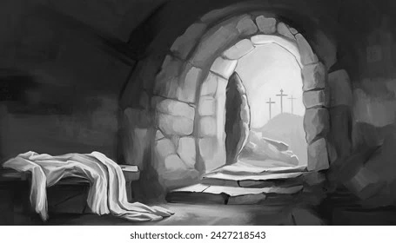

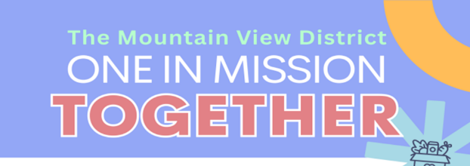



Together, the Mountain View District will host Rise Against Hunger events in three locations to help feed people around the world, while each local community group of churches will partner with local nonprofits to meet needs much more locally. Join members of all 72 Mountain View District congregations as we come together in one to pack 30,000 lbs of food AND care directly for our communities.
Locations: Heritage UMC, Lynchburg; Redwood UMC, Rocky Mount; First UMC, Martinsville
**We’d love you to RSVP so that our host locations can plan materials and projects properly. But, RSVPS are not required. We hope everyone will plan to serve as One in Mission Together on April 11. If you want to RSVP on the District’s website go to: “Mountain View District”.

DIRECTORY OF CHESTNUT HILL UNITED METHODIST CHURCH
Adam J. White | Minister
Sharon Mayhew | Director of Music
Monica Campbell | Administrative Assistant
Judy Martin | Bookkeeper
Judy Robertson  Elizabeth Nichols | Lay Leader  Missionary in Henry County

**Calendar **
Monday, 4/6 |  | Easter Holiday ~ Church Office Closed
**Looking Ahead on the Calendar **
Sunday, 4/12 | 10:00 a.m. | Choir
Thursday, 4/16 | 10:30 a.m. | Merry Martha’s Circle
Monday, 4/20 | 7:00 p.m. | Wesleyan Group @ Walker Home. Packing Kits for Conference.
Hospital: Virginia Baptist: Steve Coleman
Birthdays Coming Up: April 10-Jeanmarie M. White

For the Grocery Cart:
April ~ Chunky Soups, Fruit/Vegetable Canned Goods. Pop-top.
Easter Offering
Our goal to reach will be $6,000.00. Our Easter offering will go towards roof repair over office area. Envelopes are provided in the pew racks.

Together, the Mountain View District will host Rise Against Hunger events in three locations to help feed people around the world, while each local community group of churches will partner with local nonprofits to meet needs much more locally. Join members of all 72 Mountain View District congregations as we come together in one to pack 30,000 lbs of food AND care directly for our communities.
Locations: Heritage UMC, Lynchburg; Redwood UMC, Rocky Mount; First UMC, Martinsville
**We’d love you to RSVP so that our host locations can plan materials and projects properly. But, RSVPS are not required. We hope everyone will plan to serve as One in Mission Together on April 11. If you want to RSVP on the District’s website go to: “Mountain View District”.

DIRECTORY OF CHESTNUT HILL UNITED METHODIST CHURCH
Adam J. White | Minister
Sharon Mayhew | Director of Music
Monica Campbell | Administrative Assistant
Judy Martin | Bookkeeper
Judy Robertson  Elizabeth Nichols | Lay Leader  Missionary in Henry County


C hestnut Hill
United Methodist Church

Making disciples of Jesus Christ
for the transformation of the world.
You are welcome at Chestnut Hill UMC.

4660 Fort Avenue ~ Lynchburg, Virginia 24502
Church: 434-239-8423
Minister’s Cell: 434-944-7723, Minister’s Email: awhite@ves.org
Email: chestnuthillumc@comcast.net
On the Web at chestnuthillumc.net
Find us on Facebook: Chestnut Hill United Methodist Church

